**WEEK-1**

1. **Exercise 1: Implementing the Singleton Pattern**

**Logger.java**

public class Logger {

    private static Logger instance;

    private Logger() {

        System.out.println("Logger Initialized");

    }

    public static Logger getInstance() {

        if (instance == null) {

            instance = new Logger();

        }

        return instance;

    }

    public void log(String message) {

        System.out.println("Log: " + message);

    }}

**Main.java**

public class Main {

    public static void main(String[] args) {

        Logger logger1 = Logger.getInstance();

        logger1.log("First log message");

        Logger logger2 = Logger.getInstance();

        logger2.log("Second log message");

        if (logger1 == logger2) {

            System.out.println("Both logger instances are the same (Singleton works!)");

        } else {

            System.out.println("Different logger instances (Singleton failed)");

        }}}

**OUTPUT:**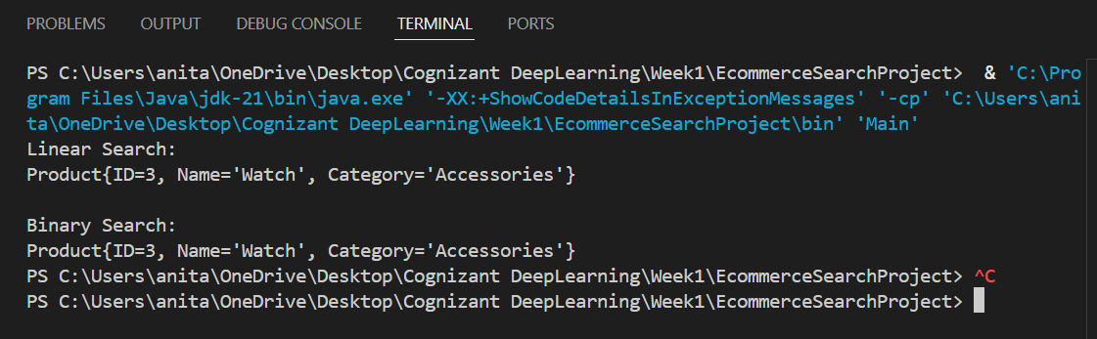

1. **Exercise 2: Implementing the Factory Method Pattern**

**Document.java**

public interface Document {

    void open();

}

**DocumentFactory.java**

public abstract class DocumentFactory {

    public abstract Document createDocument();

}

**ExcelDocument.java**

public class ExcelDocument implements Document {

    @Override

    public void open() {

        System.out.println("Opening Excel document...");

    }

}

**ExcelDocumentFactory.java**

public class ExcelDocumentFactory extends DocumentFactory {

    @Override

    public Document createDocument() {

        return new ExcelDocument();

    }}

**PdfDocument.java**

public class PdfDocument implements Document {

    @Override

    public void open() {

        System.out.println("Opening PDF document...");

    }}

**PdfDocumentFactory.java**

public class PdfDocumentFactory extends DocumentFactory {

    @Override

    public Document createDocument() {

        return new PdfDocument();

    }}

**WordDocument.java**

public class WordDocument implements Document {

    @Override

    public void open() {

        System.out.println("Opening Word document...");

    }}

**WordDocumentFactory.java**

public class WordDocumentFactory extends DocumentFactory {

    @Override

    public Document createDocument() {

        return new WordDocument();

    }}

**Main.java**

public class Main {

    public static void main(String[] args) {

        DocumentFactory wordFactory = new WordDocumentFactory();

        Document wordDoc = wordFactory.createDocument();

        wordDoc.open();

        DocumentFactory pdfFactory = new PdfDocumentFactory();

        Document pdfDoc = pdfFactory.createDocument();

        pdfDoc.open();

        DocumentFactory excelFactory = new ExcelDocumentFactory();

        Document excelDoc = excelFactory.createDocument();

        excelDoc.open();

    }}

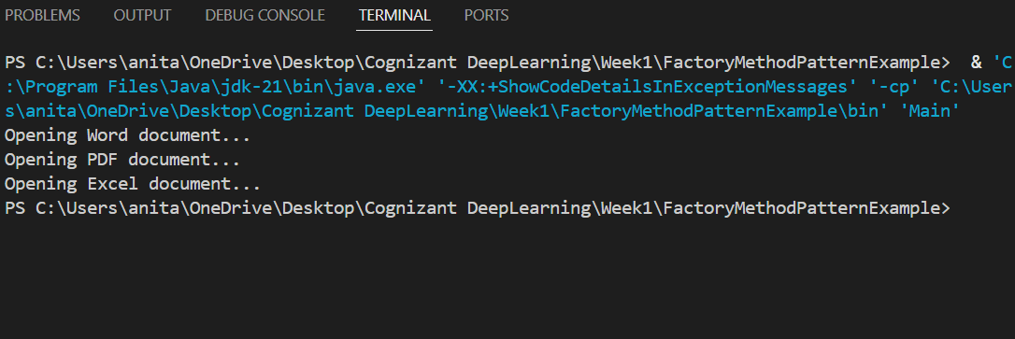

1. **Exercise 2: E-commerce Platform Search Function**

**Main.java**

public class Main {

    public static void main(String[] args) {

        Product[] products = {

            new Product(1, "Laptop", "Electronics"),

            new Product(2, "Shoes", "Footwear"),

            new Product(3, "Watch", "Accessories"),

            new Product(4, "Phone", "Electronics")

        };

        System.out.println("Linear Search:");

        Product found1 = Search.linearSearch(products, "Watch");

        System.out.println(found1 != null ? found1 : "Product not found");

        System.out.println("\nBinary Search:");

        Product found2 = Search.binarySearch(products, "Watch");

        System.out.println(found2 != null ? found2 : "Product not found");

    }}

**Product.java**

public class Product {

    private int productId;

    private String productName;

    private String category;

    public Product(int productId, String productName, String category) {

        this.productId = productId;

        this.productName = productName;

        this.category = category;

    }

    public int getProductId() {

        return productId;

    }

    public String getProductName() {

        return productName;

    }

    public String getCategory() {

        return category;

    }

    @Override

    public String toString() {

        return "Product{" +

                "ID=" + productId +

                ", Name='" + productName + '\'' +

                ", Category='" + category + '\'' +

                '}'; }}

**Search.java**

import java.util.Arrays;

import java.util.Comparator;

public class Search {

    public static Product linearSearch(Product[] products, String name) {

        for (Product p : products) {

            if (p.getProductName().equalsIgnoreCase(name)) {

                return p;

            }}

        return null;

    }

    public static Product binarySearch(Product[] products, String name) {

        Arrays.sort(products, Comparator.comparing(Product::getProductName));

        int left = 0;

        int right = products.length - 1;

 while (left <= right) {

            int mid = (left + right) / 2;

            int result = name.compareToIgnoreCase(products[mid].getProductName());

            if (result == 0) return products[mid];

            else if (result < 0) right = mid - 1;

            else left = mid + 1;

        }

        return null;

    }}



1. **Exercise 7: Financial Forecasting**

**Financial Forecasting.java**

public class FinancialForecast {

    // Recursive method to calculate future value

    public static double futureValueRecursive(double principal, double rate, int years) {

        if (years == 0) {

            return principal;

        }

        return futureValueRecursive(principal, rate, years - 1) * (1 + rate);

    }

    // Memoized version to optimize

    public static double futureValueMemo(double principal, double rate, int years, double[] memo) {

        if (years == 0) return principal;

        if (memo[years] != 0) return memo[years];

        memo[years] = futureValueMemo(principal, rate, years - 1, memo) * (1 + rate);

        return memo[years];

    }

    public static void main(String[] args) {

        double principal = 10000; // Initial amount

        double rate = 0.07;       // Annual growth rate (7%)

        int years = 10;           // Number of years to forecast

        // Using simple recursion

        double result = futureValueRecursive(principal, rate, years);

        System.out.printf("Future Value (Recursive) after %d years: ₹%.2f\n", years, result);

        // Using memoization

        double[] memo = new double[years + 1];

        double optimizedResult = futureValueMemo(principal, rate, years, memo);

        System.out.printf("Future Value (Memoized) after %d years: ₹%.2f\n", years, optimizedResult);

    }

}

